ExternalApi.java
package com.example;
public interface ExternalApi {
String getData();
}
MyService.java
package com.example;
public class MyService {
private ExternalApi api;
public MyService(ExternalApi api) {
this.api = api;
}
public String fetchData() {
return api.getData();
}
}
MyServiceTest.java
package com.example;
import org.junit.Test;
import static org.junit.Assert.assertEquals;
import static org.mockito.Mockito.*;
public class MyServiceTest {
@Test
public void testExternalApi() {
ExternalApi mockApi = mock(ExternalApi.class);
when(mockApi.getData()).thenReturn("Mock Data");
MyService service = new MyService(mockApi);
String result = service.fetchData();
assertEquals("Mock Data", result);
}
}
Pom.xml added dependency
<dependencies>
<dependency>
<groupId>junit</groupId>
<artifactId>junit</artifactId>
<version>4.13.2</version>
<scope>test</scope>
</dependency>
<dependency>
<groupId>org.mockito</groupId>
<artifactId>mockito-core</artifactId>
<version>5.12.0</version>
<scope>test</scope>
</dependency>
</dependencies>
Output:
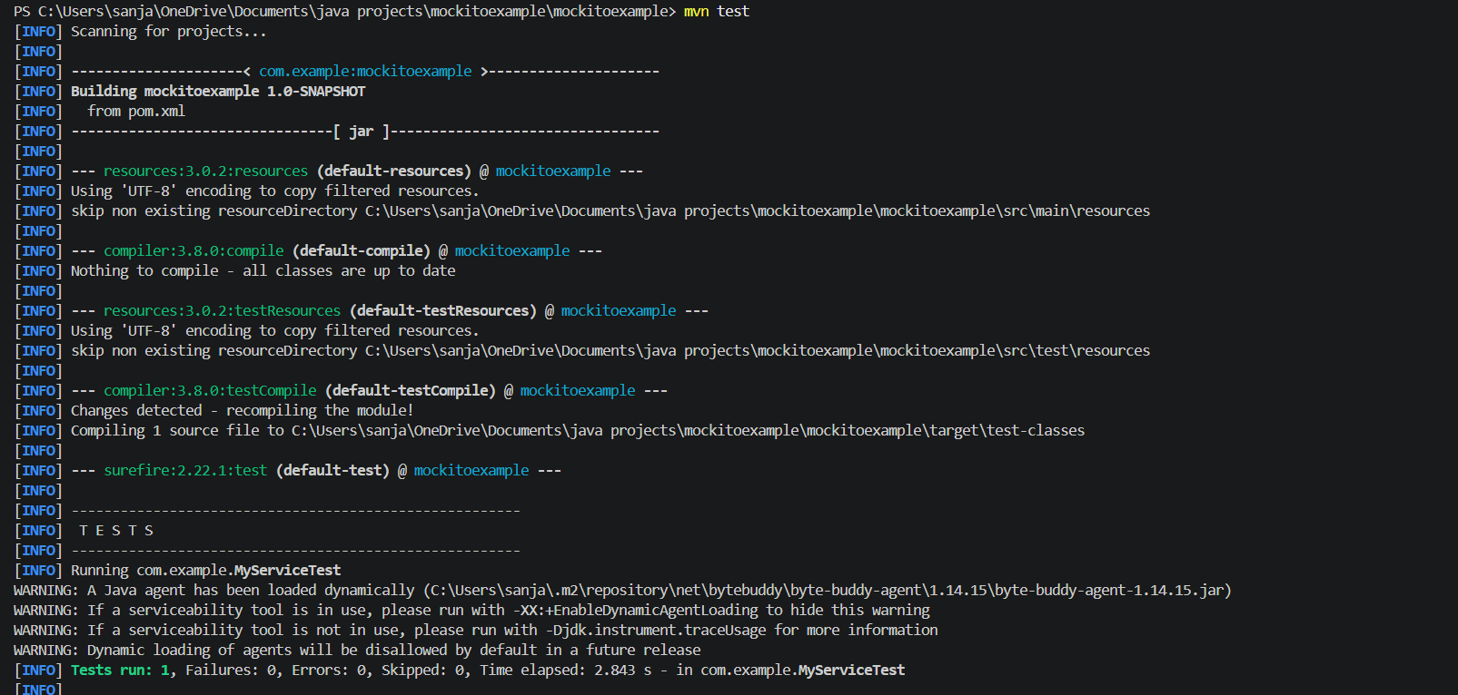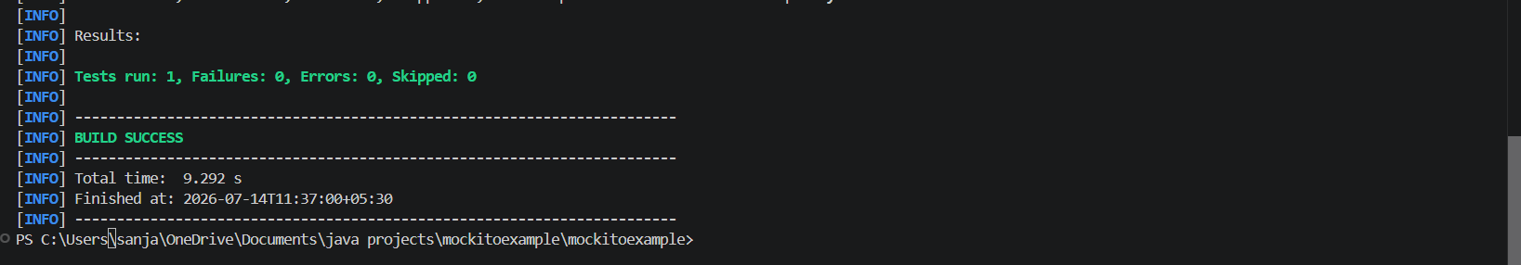
Images:
